

**MS WORD**

**365**

WORD EXERCISE 2

Follow the instructions for each task below.

1. Insert today's date below this sentence.

**Today’s Date:**

1. In In this exercise we will be using some of the following tools.

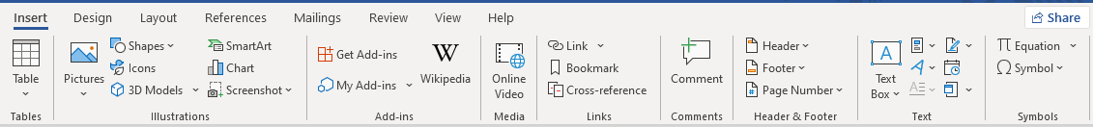

Date and time

Tables

Illustrations

|  |
| --- |
| Tables tools |

|  |
| --- |
| Illustrations tools |

Header and Footer

1. Insert a table below, the table must have 5 rows and 5 columns.
2. Insert 3 shapes below: a rectangle, a triangle and a cube.

Note: the shapes option is in the Illustrations group.

1. Add a Header and Footer from the Header and Footer group.

* Use your first and last name as Header(left).
* Use page numbers as Footer(center).

1. Add three icons to your Quick Access Toolbar.
2. Save this Document as "Word Project 2- your Initials”.