

**MS WORD**

**365**

WORD EXERCISE 2

Follow the instructions for each task below.

1. The icon that says show me how, is the video that shows you how to do each step, it will be at the top at the beginning of each exercise.
2. Insert today's date below this sentence.

**Today’s Date:**

1. In In this exercise we will be using some of the following tools.

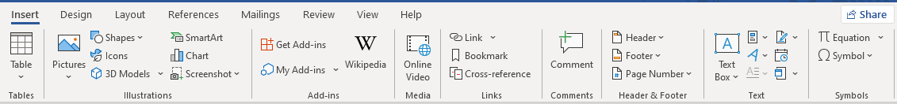

Date and time

Tables tools Illustrations tools Header and Footer

1. Insert a table below, the table must have 5 rows and 5 columns.
2. Insert a rectangle shape below, the shapes option is in the Illustrations group.
3. Add a Header and Footer from the Header and Footer group.

* Use your first and last name as Header.
* Use page numbers as Footer.

1. Add the Save icon to your Quick Access Toolbar.
2. Save this Document as "Word Exercise 2 and add your Initials”.